CMPT 275 Software Engineering 1

Group 4

Team Name: Dancing Dragon

Project Proposal

Team Members:
- Tianxiao Liu-301297598
- Liangchen Zou - 301270495
- Sachin Momuli - 301297150
- Dongyue Shi - 301294332
- Evan Lee- 301282245
- Sterling Smith

TABLE OF CONTENTS

Revision history ………………………………………………………………………………………. 2
Project summary ………………………………………………………………………………………. 3
Project overview ……………………………………………………………………………………….. 3
Project planning ……………………………………………………………………………………….. 4
Project schedule ……………………………………………………………………………………….. 5
Risk management ……………………………………………………………………………………... 7
Project organization and staff planning …………………………………………………………... 9
References …………………………………………………………………………………………….. 10
Appendix - A …………………………………………………………………………………………... 11
Revision history

Revision | Status | Publication/Revision on Date | By
1.0 | Created | September 18, 2019 | Evan Lee, Dongyue Shi, Liangchen Zou, Sachin Momuli, Sterling Smith, Michael Liu
3.0 | Final Revision | September 25, 2019 | Evan Lee, Dongyue Shi, Liangchen Zou, Sachin Momuli, Sterling Smith, Michael Liu

Project summary
The main focus of this summary is to discuss the idea and usefulness of our app named “Parkinhelp” which is aimed at assisting the lives of Parkinson’s patients in many ways. This app will not only be beneficial to the patient themselves but also to the patient’s therapist. The app’s primary function will be to assess the daily condition of the patient and suggest the proper type and intensity of exercise to perform. This assessment, meant to be completed in the morning, measures physical symptoms and takes input from the patient to determine their state. After it is used to suggest the proper stretch or exercise, this information is then sent to the patient’s therapist for further analysis and use during patient-therapist meetings.
In addition, there will be several additional features to further ease the patient’s life, such as a Pill scheduler and a direct communication channel to their therapist. Overall this app is meant to work to make the patient more comfortable throughout the day by suggesting therapy/exercises were also aiding organize and structure their lives. It is aimed squarely at patients who’s Parkinson’s has not yet developed too severely allowed them to still use a smartphone efficiently. It is not meant to aid severe cases. We hope that this app will function overall as a daily assistant to make patients' lives easier.

Project overview
The stakeholders in this project consists of the six group members in our team. We all have an equal stake in the success of the app since we will all be receiving the same final grade. The intended users of our app will be Parkinson’s patients with mild to moderate symptoms. Since our app will require the user to interact directly with the UI and it is not strictly meant to be used with a caregiver, anyone with symptoms too severe to properly operate a smartphone may not be able to benefit. It will most likely be used by patients who are already active, or have experience exercising on a regular basis.
While exercise and physical activity aren’t strictly necessary for Parkinson’s patients, and exercise cannot stop the progression of the disease, exercising can produce great benefits and slow down progression. “People with Parkinson’s who exercise fare better in the long run than people with Parkinson’s who do not exercise”[5]. The Parkinson’s foundation states that there is no such exercise that can be recommended for every person diagnosed with Parkinsons. It’s unique to each patient based on their challenges and symptoms”[4] [5]. This can make it intimidating and cumbersome for patients to start exercising in the first place, as each patient must do their own research and build off their own determination to start a routine. The type of exercise a patient should be doing is highly dependant on the individual patient.
Parkinhelp is designed to solve the difficulty and initiative with exercising. A patient armed with our app would simply need to fill out a short survey of their current activity, condition and symptoms. Based on the information, patients are advised with consistent and daily exercise regiment. The app with be loaded with many exercises, including flexibility, aerobic, and resistance exercising. It then suggests a few exercises for the patient each day to perform based on the results of the condition survey each user fills out. These exercises will then be updated as time goes on depending on the patient’s symptoms and condition. For instance, intensity of the exercises can be increased by the patient once the patient starts becoming stronger and can better control their condition.
The core functionality of the app will be to effectively determine accurate and helpful exercise routines to Parkinson’s patients in the easiest way possible as outlined above. However, there will be few more added features to further simplify the lives of Parkinson’s patients. The condition survey each patient takes can be sent to the patient’s doctor or caregiver with patient’s consent. This gives them the opportunity to have the data they could not extract themselves, to really customize and assist the patient as best as possible on their future appointments.
Our app will also provide the patient with an in-app calendar with the ability to fully schedule their medication routine and be provided with real time reminders. Parkinson’s patients have a hard time keeping up with their medication schedule[3]. As Parkinson’s treatment can involve several medications, often changing from time to time based on effectiveness, might get difficult for the patient to keep track of all the medications and appropriate time to consume them. Integrated into our app will be the ability to easily sync a medication routine into the calendar with pop up notifications (pill reminder), making it far easier to stay on top of.
Overall our app “ParkinsHelp” strives to simplify and organize the lives of patients, taking the effort and initiative for the patient to make sure they stay as healthy as possible.

Project planning

For this project, we will be creating a new document on every meeting to show the topics discussed and changes made to previous versions. However, we will also be using version control (GitHub) to keep track of the software developments in mobile application. We are determined to have one or two meetings each week to go over the changes in the project, discuss new ideas and solve issues put forward by team members. Although we will not be spending a significant amount of money, we are willing to put our time into this project, estimated around 12 hours per week or more (if needed) to be able to improve the existing plan. The scope of this project doesn’t need a stakeholders as of this point. Any team member will be able to contact other members through their personal social media and through their sfu email. Our website can be accessed through the link shown below

https://sites.google.com/view/cmpt275group4/home

The scope of this project doesn’t need to have any external stakeholders other than 6 team members. Any team member will be able to contact other members through their personal social media accounts and through their sfu email.

Project schedule

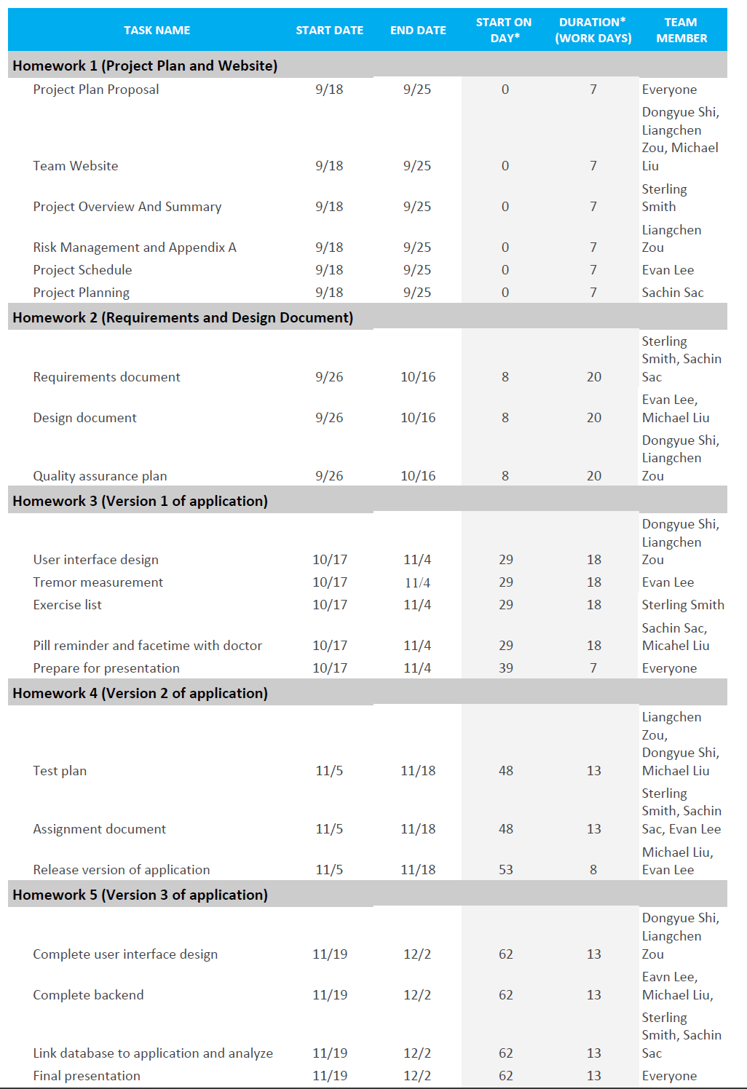
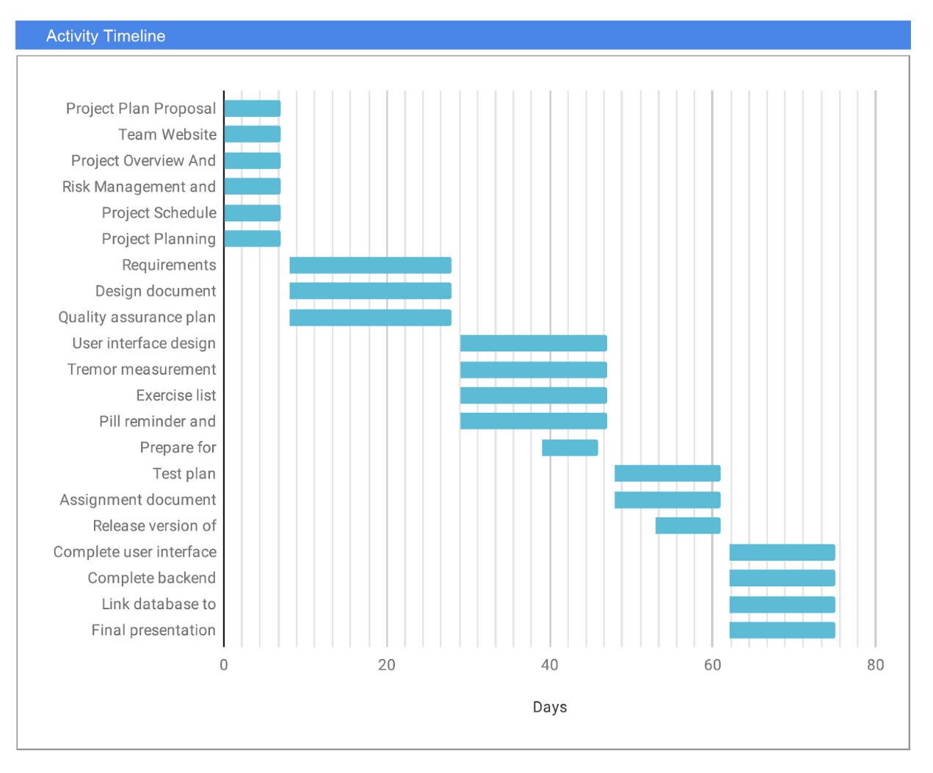

Risk management

Risks | Potential Impact on Project (what scale do you use?) | Likelihood of Occurrence | Impact area | Mitigation Strategy
Estimation Risk
Time required is underestimated | 5 (severe) | high | project and product | Follow the time schedule and keep effective group meeting; investigate buying-in components; investigate use of program generator
Size of software is underestimated | 4 (significant) | high | project and product | Investigate buying-in components; investigate use of program generator
People Risk
Key staff are ill and unavailable at critical times | 4 (significant) | moderate | project | Reorganize team so that there is more overlap of work and people therefore understand each other’s jobs
Required training is not available | 3 (moderate) | moderate | project | Investigate buying-in components; ask for help from experienced person
Tools Risk
Software tools cannot be integrated | 2 (minor) | high | project | Investigate higher-performance workstations
Code is inefficient | 1 (minimal) | moderate | project | ask for help from experienced person

Project organization and staff planning
Name: Sterling Smith
Email: srs17@sfu.ca
Role: Project Manager
Bio:
Sterling is entering into fourth year Computer Engineering and I have completed one coop term. He will be the project manager, organizing and structuring the way we complete the assignment. While Sterling has plenty of experience in C, Python, and Java, he has not used Swift before. I am looking forward to seeing the development process for IOS.

Name: Liangchen Zou
Email: lza92@sfu.ca
Role: Application Developer
Bio:
Liangchen is a fourth year Computer Engineering student and he has completed one coop term. He will be writing codes with other team members to complete the project. He has experience in C++, Python, assembly language and Javascript. He is excited to learn new skills of developing an IOS application.

Name: Sachin Momuli
Email: smomuli@sfu.ca
Role: Application Developer
Bio:
Sachin is a fourth year Computer Engineer studying at Simon Fraser University with a keen interest in aspects of technology and computers. Having to work in a field as firmware engineer, he was able to gain insight on working nature of an industry, develop software applications for windows and linux platforms to mediate data transfer between devices, programming in C++, Tcl & bash. Never having to work on swift before, will be a fun and challenging process to develop an IOS app which will be useful for a significant amount of people.

Name: Evan Lee
Email: evan_lee_2@sfu.ca
Role: Backend developer
Bio:
Evan is an Engineering Science student majoring in Computer Engineering at Simon Fraser University. Evan has a year of industry experience as a software engineer from his co-op terms, where he has gained experience with C/C++, Java, Python, Javascript and SQL. In his spare time he spends it exercising, playing basketball, and reading. As IOS development is an unfamiliar domain for Evan, he is excited to pick up a new skill into his repertoire.

Name: TianXiao Liu
Email: txliu@sfu.ca
Role: Software developer
Bio:
TianXiao is a fourth year computer engineering studying at SFU, he is interested in how the machine works and computer. He used to work in Star Solution Inc and Hisense Inc as a system Engineer intern. So he is good with embedded system and he is also doing our website design.

Name: Dongyue Shi
Email: dongyues@sfu.ca
Role: Backend developer
Bio:
Dongyue is a 4th year computer engineering student at Simon Fraser University. Dongyue has been working for the website during the coop term, where he also implemented his skill of C+ +,Java,Python and HTML. He has not experienced with IOS and ANDROID before but he is excited to learn new skills.

References
Ref: World Wide Web Author(s)*. “Title.” Internet: complete URL, date updated* [date accessed]. M. Duncan. “Engineering Concepts on Ice. Internet: www.iceengg.edu/staff.html, Oct. 25, 2000 [Nov. 29, 2003].

- Roisin McCormack. “Five of our favourite apps for people with Parkinson's” Internet:https://parkinsonslife.eu/five-of-our-favourite-apps-for-people-with-parkinsons/. Oct 25, 2018 [Accessed: Sept 24, 2019]

- Jonah Comstock. “Study: App accurately tracks Parkinson’s disease symptoms.” Internet:www.mobihealthnews.com/content/study-app-accurately-tracks-parkinsons-disease-symptoms, Sept 04, 2018 [Accessed: Sept 22, 2019]

- Stephanie Watson. “ Tips to keep track of your Parkinson’s Medication” Internet:https://www.healthline.com/health/parkinsons/keep-track-medication#2. Aug 19, 2019[Accessed: Sept 21, 2019]

- Parkinson’s Foundation . “Exercise” Internet:https://www.parkinson.org/Understanding-Parkinsons/Treatment/Exercise. *** __, ____[Accessed: Sept 21:2019]

- Parkinson Society Canada. “Exercise for people with parkinson’s” Internet:https://www.parkinsons.va.gov/NorthWest/Documents/Pt_ed_handouts/Exercise_for_PD_1-20-12.pdf. July 03, 2007 [Accessed: Sept 23, 2019]

Appendix - A
Group # and name: Group 4 / Dancing Dragon
Purpose of Meeting: arrange the role of each member and discuss project ideas that we can do
Data/Time: Sep. 18 2019 / 1.5 hours
Chair: 6
Attendee: All members
Absent: Nobody
Topic | Discussion | Action/Decision | Person responsible/Due date
1: project website | Discussed on which technologies to use. Which language for the backend/frontend and where to host the server. | Set up a website according to the requirements / We will use Google Sites to make our webpage | Tianxiao Liu and Dongyue Shi / Sep. 23rd 2019
2: project plan | Assigned each section to a team member. | We assigned tasks to each member / See details in the project plan | Each person is responsible for some part(s) / Sep. 23rd 2019
3: project ideas | Brainstormed project ideas for application.  Referenced various online resources. | We came up with some ideas that are not too difficult for us to accomplish / See details of ideas in the project plan | Everyone / Sep. 23rd 2019

Group # and name: Group 4 / Dancing Dragon
Purpose of Meeting: to make sure everyone has started working on his part(s)
Data/Time: Sep. 20 2019 / 1 hour
Chair: 6
Attendee: Sterling Smith/ Evan Lee/ Dongyue Shi/ Liangchen Zou/ Tianxiao Liu
Absent: Sachin Momuli
Topic | Discussion | Action/Decision | Person responsible/Due date
1: Problems encountered when doing our work | Everyone talked about their problems | All members worked together to solve problems / All problems solved | Everyone / Sep. 20 2019
2: Complete missing information | Information shared | Biography containing information of everyone is shared in the group chat / Information shared is put on our website | Everyone / Sep. 20 2019

Group # and name: Group 4 / Dancing Dragon
Purpose of Meeting: make sure everyone has (almost) done his parts
Data/Time: Sep. 23 2019 / 1 hour
Chair: 6
Attendee: All members
Absent: None
Topic | Discussion | Action/Decision | Person responsible/Due date
1: Check if everyone is done with his parts | We checked everyone’s work | We checked every single task in our project plan / Almost all parts done | Everyone / Sep. 23 2019
2: Make up any missing work | We discussed about missing information and parts | Everyone got the information he wants and will finish his part(s) within 1 day / project plan and project website will be done soon | Everyone / Sep. 23 2019

